INTRODUCTION TO hfss: transmission lines and wire antennas
Course EE-446: Antennas

PART 1: HFSS INTERFACE AND 3D MODELS
In this session, you will follow a tutorial of ANSYS Electronics Desktop (also named HFSS), a software widely used in electromagnetic and antenna simulations. The assistants will design a microstrip transmission line as an example, that you will simulate on your workstations and obtain the results, as a first contact with the tool. This tool will be used in later sessions to simulate other transmission lines and antennas, that will add a practical and interactive layer to the contents from the course.

Software interface
There are six distinct sections/windows of interest within the HFSS user interface:
- The project tree, where you can see the active project and the different designs contained in it.
- The history tree, containing all the components of the design, and the history of actions taken to create them.
- The 3D modeler window, where you can see the 3D representation of the components listed in History tree.
- The properties window, which lists the variables of the design, as well as specific properties of individual elements from the history tree, when selected.
- The message window, where the program logs information, warning and error messages
- The progress windows, where the system informs the user of the status of the simulations being run.

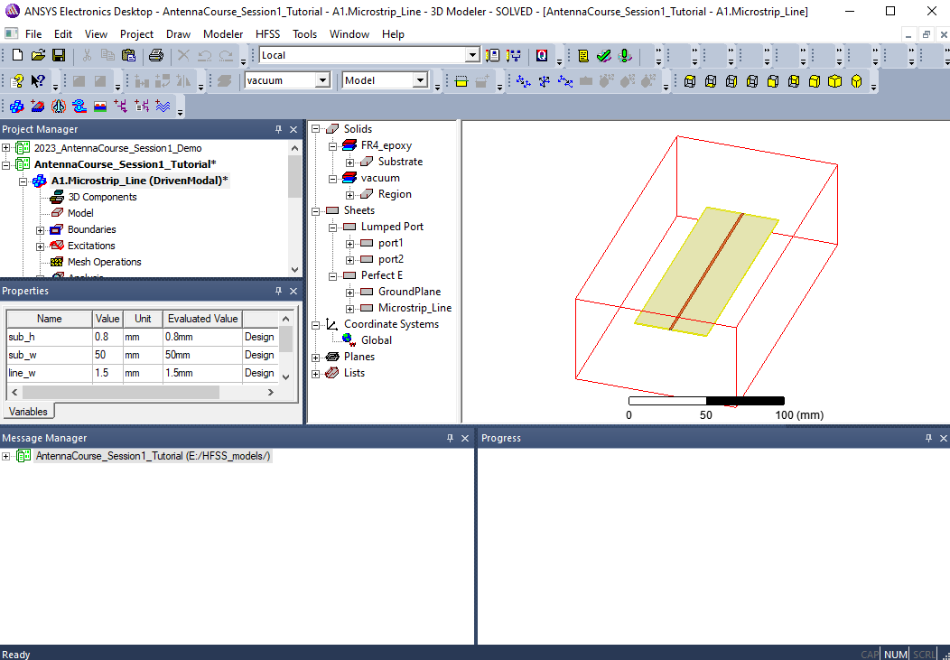
Figure 1. ANSYS HFSS interface.
The largest window is the 3D modeler window, where you can see the 3D model of the simulated device. You can change the view (zoom, rotate, etc…) using the icons highlighted in red in the following screenshot:
Figure 2. HFSS menu with view options highlighted.
You can also access these buttons via shortcuts:
- Drag: SHIFT + Left Mouse Button
- Rotate model: Alt + Left Mouse Button
- Zoom in/out: Alt + SHIFT + Left Mouse Button

Example: Microstrip line design
Microstrip transmission lines are widely used as they are easily fabricated and integrated on PCBs. These lines are simple to model in HFSS, and are therefore convenient to get familiar with the software and the operation of transmission lines.

Creating the model
First of all, you need to model the geometry of a microstrip transmission line, as it is depicted in Figure 3. It consists of a substrate, made of FR4-epoxy (a common material for PCB fabrication), with a ground plane on one layer (bottom in this case), and a line on the other.

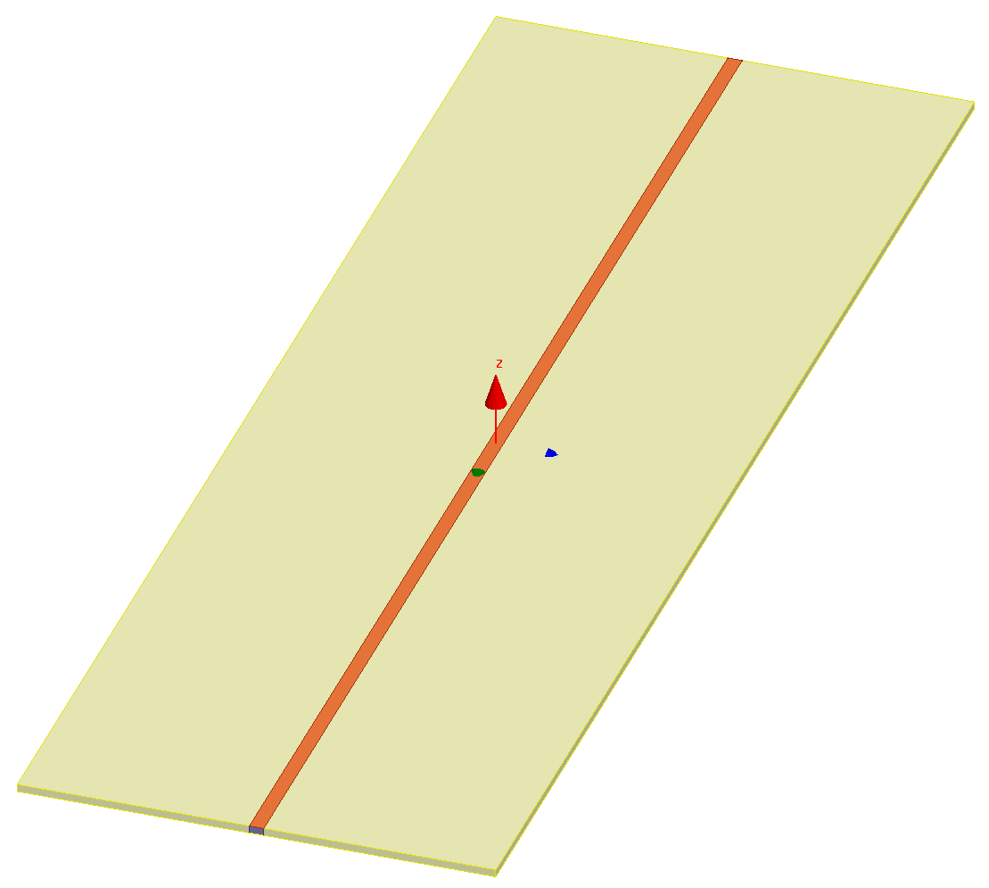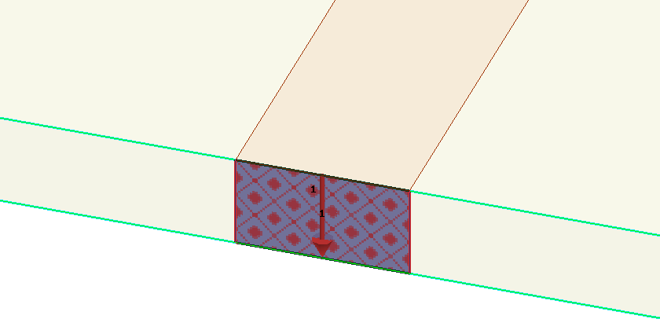
Port 2
Microstrip line
Substrate
Port 1
Port

Figure 3. Microstrip line modelled in ANSYS Electronics Desktop.

The description of all the geometries needed for the design of the microstrip transmission line, are gathered in the following Table:
Geometry | Type/Material | Design parameters (variable name) | Value | Remark
Substrate | Rectangular box made of FR4  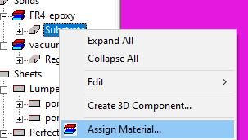 | Substrate thickness (sub_h) | 0.8 mm | It affects the input impedance of the line, as it controls the separation between the line and the ground.
Substrate |  | Substrate width (sub_w) | 50 mm | It controls the size of the substrate and the ground plane. Should be reasonably larger than the width of the line.
Substrate |  | Substrate length (sub_l) | 150 mm
Ground plane | Rectangular sheet (with perfect electric conductive boundary)  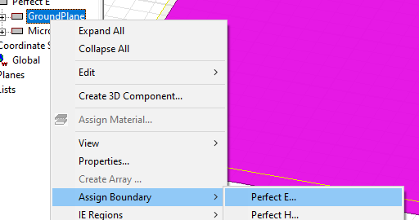 | ground width (sub_w) | 50 mm
Ground plane |  | ground length (sub_l) | 150 mm
Line | Rectangular sheet (with perfect electric conductive boundary)  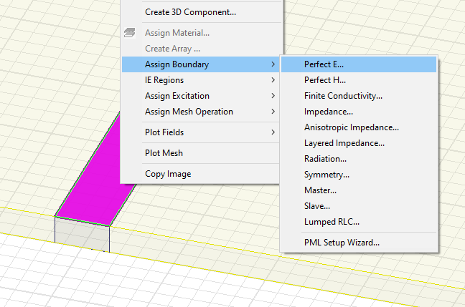 | Line width (line_w) | 1.5 mm | It controls the input impedance of the line.
Line |  | Line length (sub_l) | 150 mm
Ports | Lumped port (with integration line from conductor to conductor)  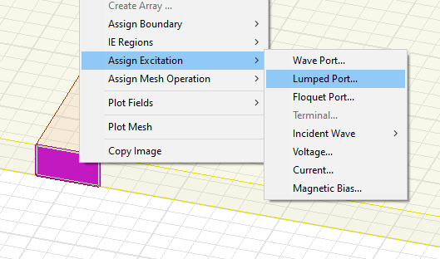 | Port height (sub_h) | 0.8 mm | Two ports, on either sides of the substrate.
Ports |  | Port width (line_w) | 1.5 mm | Two ports, on either sides of the substrate.

The simulator allows to parametrize the dimensions (among other things) of your design; this means that the dimensions are dynamic and you can modify them by just changing the numerical value of the corresponding variable. To access these variables proceed as follows:

- Select the design in the Project manager by left- clicking on its name.
- The list of properties is shown in the properties window.
- To modify a variable, you must modify its value in the corresponding column (Value). When introducing the number, pay attention to the units
- Column “Evaluated Value” always shows the final value interpreted by HFSS.

Simulation Setup
To define the simulation setup, one needs to know the frequency of operation of the device. In this case, you will evaluate the transmission line between 2 and 3 GHz.
- Create a region that to define the radiation boundaries. These should have a space of at least λ/4 from the edges of the model, and you can do that automatically using the icon 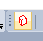 to create a region. The following window will pop up, in which you can specify the distance, even using a variable for λ. In this case, we calculate the wavelength at the lowest frequency of the band using the relation λ=c/f. Therefore, at 2GHz we can define the value of the variable “lambda” as 150mm.

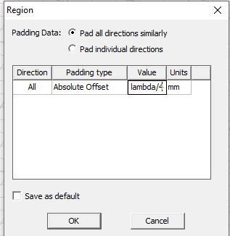
Figure 4. Region menu for defining radiation box.

- Assign radiation boundary. Right click on the region > Assign Boundary > Radiation and click OK.
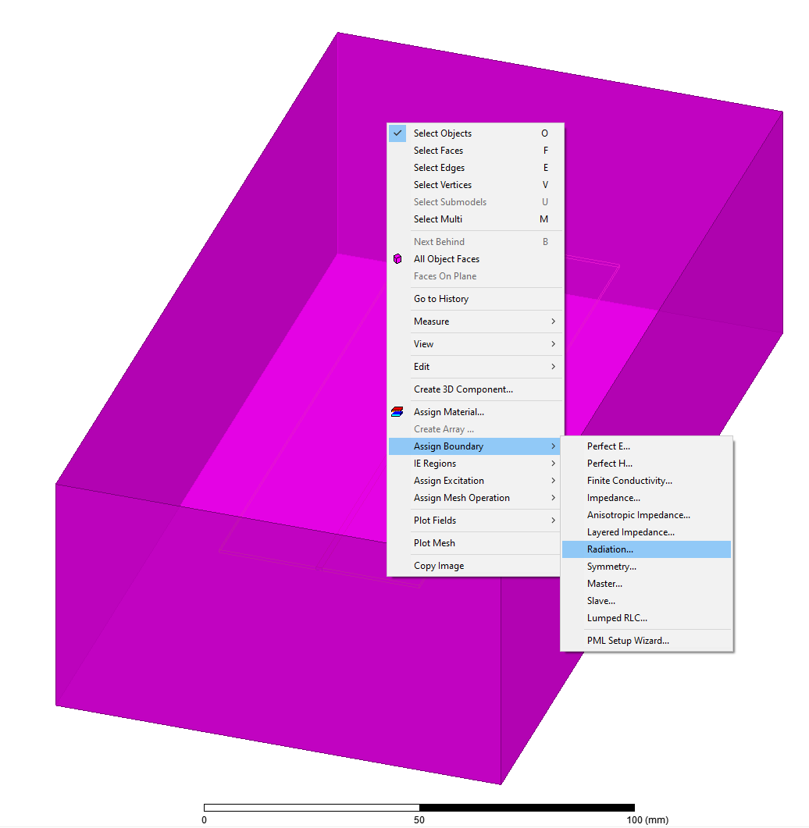 | 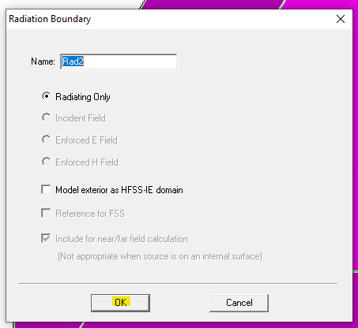
Figure 5. Procedure to assign radiation boundary to the created region box.

- Define the Solution Setup. Right click on Analysis > Add Solution Setup, and fill in the setup as follows:

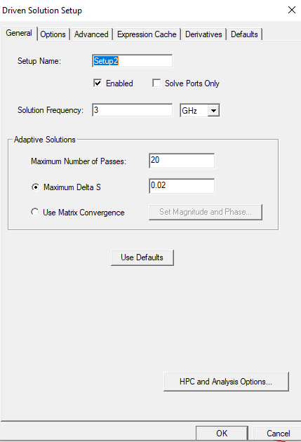 | 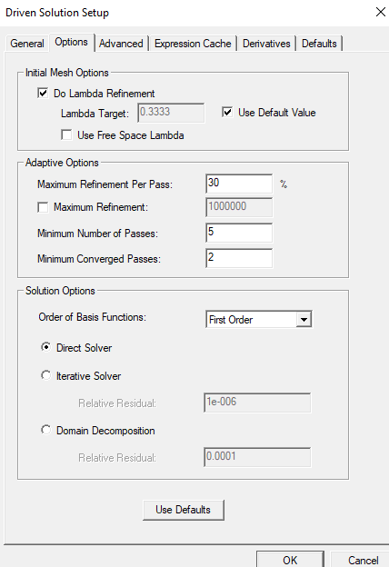

Figure 6. Definition of the Solution Setup.

- Define the frequency sweep. Right click on the newly created Solution Setup, and on “Add Frequency Sweep”, and specify the frequency band.

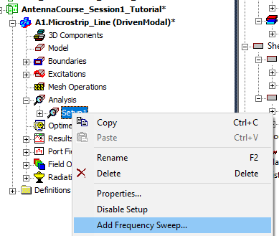 | 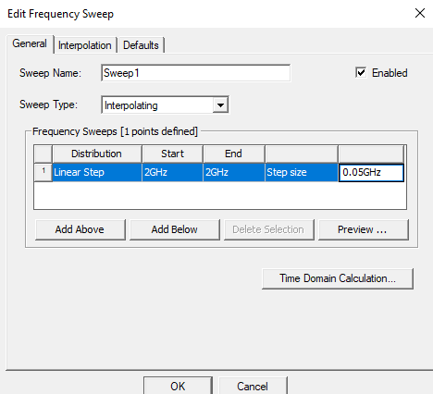
Figure 7. Definition of the Frequency Sweep.

- Define the radiation setup. On the project tree, right click on Radiation > Insert Far Field Setup > Infinite Sphere

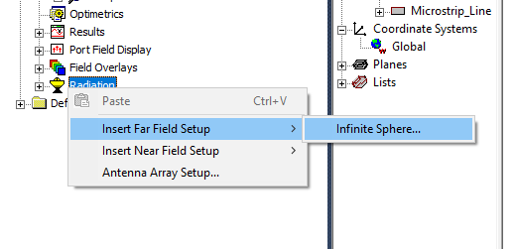 | 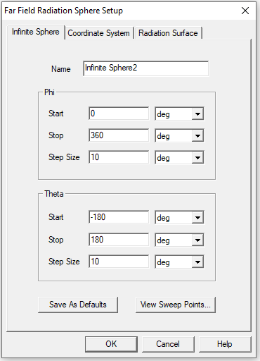
Figure 8. Radiation setup definition.

Running simulations
Before running simulations, the design has to be completed, the excitation defined, and the frequency of the simulation set-up. To run the simulation, you must proceed as follows:
- Ensure that the active design is the desired one, by left-clicking on its name in the Project Manager Window.
- To run the simulation, you can click on the Exclamation button . Alternatively you can right-click on Setup1 and select “Analyze”.
- The simulation will start directly, and you can follow its progress in the Progress Window.

Generating the Results
HFSS allows to plot the results of different parameters. This is done in the branch “Results” from the Project Manager window.
To access them, you can left-click on Results in the Project Manager window: all the available plots will be visible (red rectangle in the following screenshot). By left-clicking on the desired plot (double-click on the plot name or single click on the small icon on the left of the name).
The reflection and transmission coefficients of the transmission line can be generated by right clicking on “Results>Create Modal Solution Data Report>Rectangular Plot”, and selecting the parameters S(1,1) and S(2,1), that we express normally in dB.

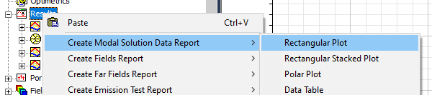
Figure 9. Menu for generating results.

The reflection and transmission coefficients of the designed microstrip transmission line are represented in red and purple in the Figure, respectively, and allow us to understand how much power is accepted by the line and transmitted from one port to the other.

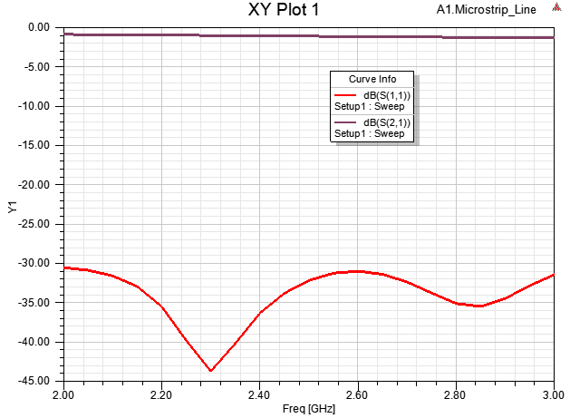
Figure 10. Obtained S parameters for the designed microstrip line.

PART 2: TRANSMISSION LINES

Microstrip line
In this exercise session, you will work with transmission lines, using ANSYS Electronics Desktop to simulate the behaviour of these devices. In Part 1, we learnt to use the simulator by designing a microstrip transmission line. We use this design as a starting point of this session on waveguides, as it will help the student to interpret the results and to complete the understanding of the functioning of transmission lines. All the details to design this line, shown in Figure 1, are described in detail in Part 1 of this document. All the designs in Part 2 are already modelled and provided to the student in the file “2025_AntennaCourse_Part2_StudentVersion”. The design of the microstrip line is included in this file, as a design named “A.Microstrip_Line”.

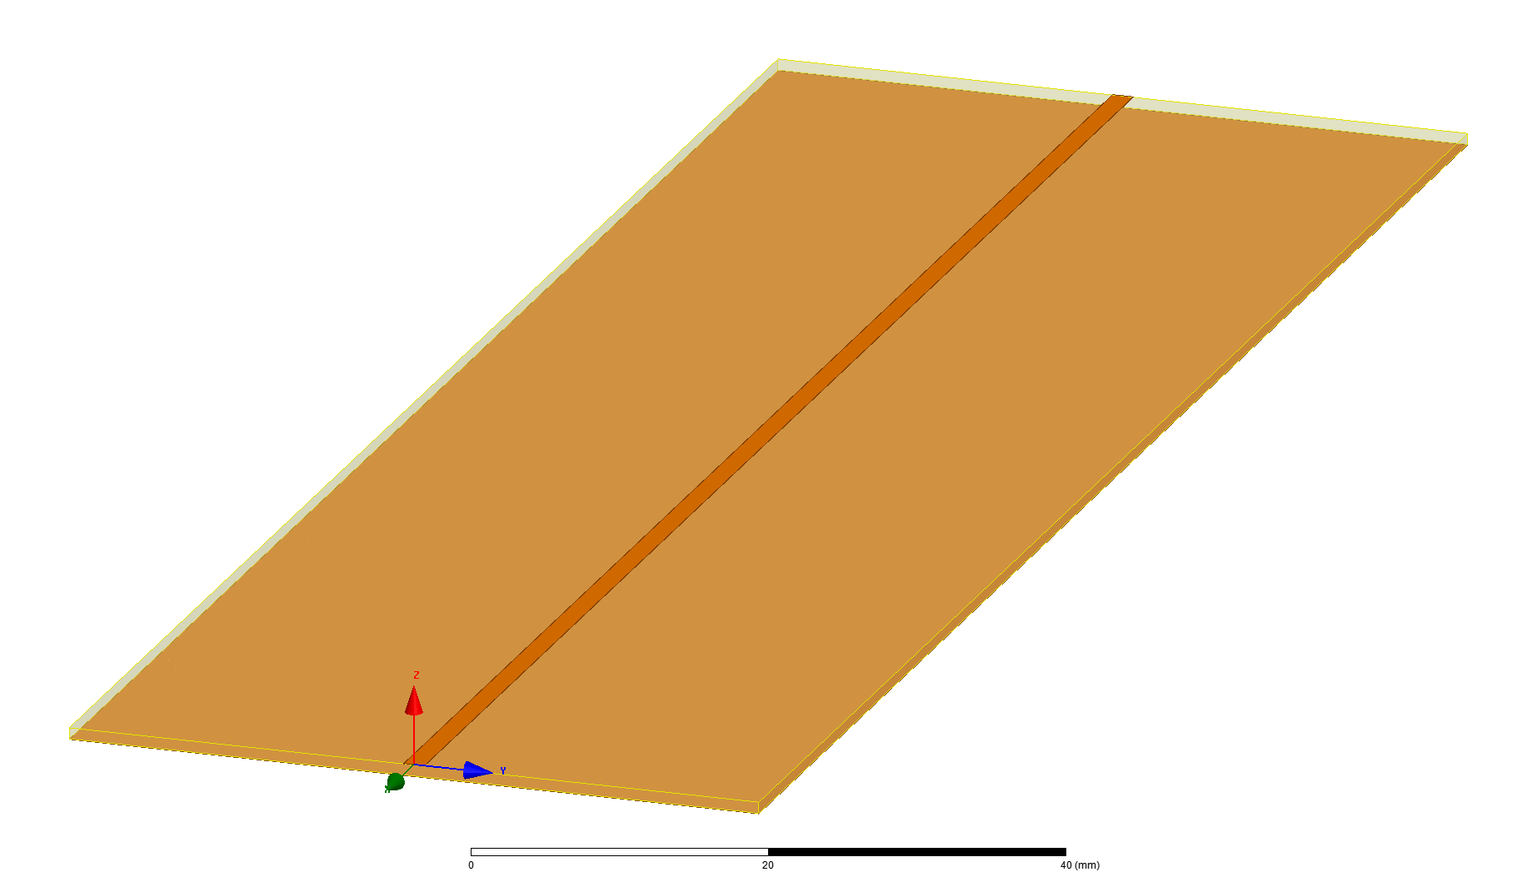
Figure 11. Microstrip line modelled in ANSYS Electronics Desktop, during the Session 1 of the course.

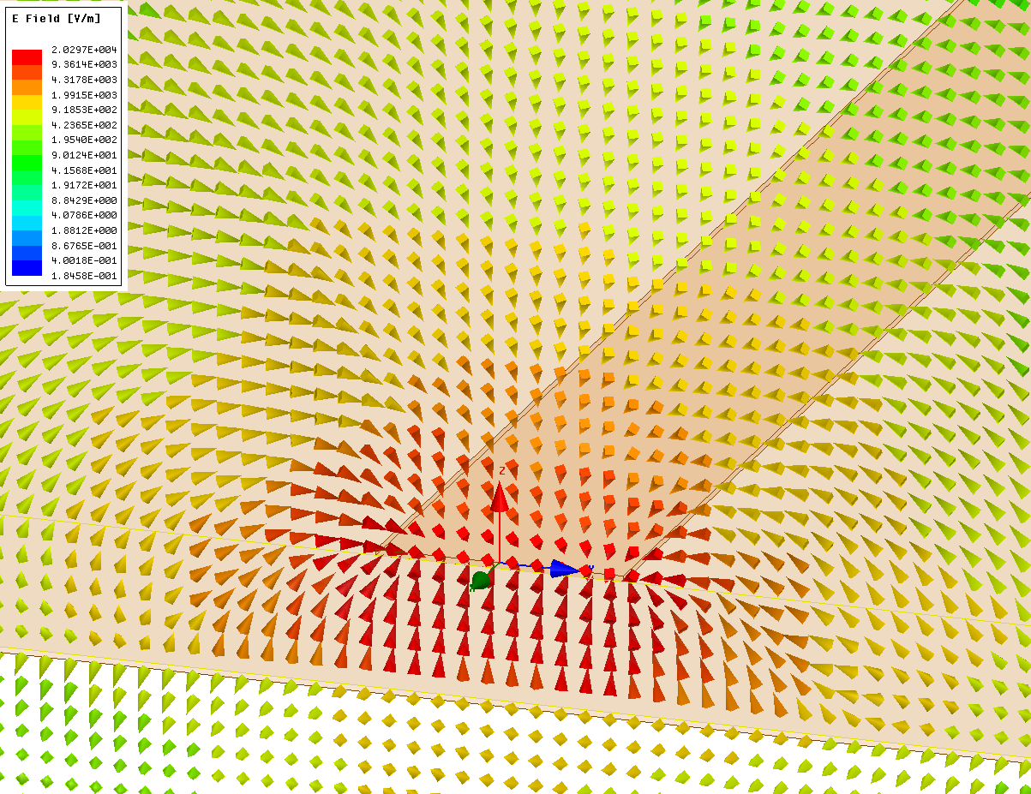
Figure 12. Electric field for the microstrip line in Figure 1.

There are two important parameters to characterize the performance of a transmission line: how much power it accepts from the source, and how much power it transfers from one port to another. These two are quantified by means of the reflection and transmission coefficient, respectively.
In the Results section in the project tree in Ansys Electronics Desktop, you can generate the reports for the reflection and transmission coefficients of the microstrip line, which should look as shown in Figure 13.

Figure 13. Reflection (red) and transmission (purple) coefficients for the microstrip line model.

Twin wire line
We will study the behaviour of a different type of transmission line: a twin-wire line, with a geometry similar to the model in Figure 14. The name of the design is B1.TwinWire_Line. A twin-wire line consists of two lines that couple to each other, generating the electric field distribution in Figure 5.

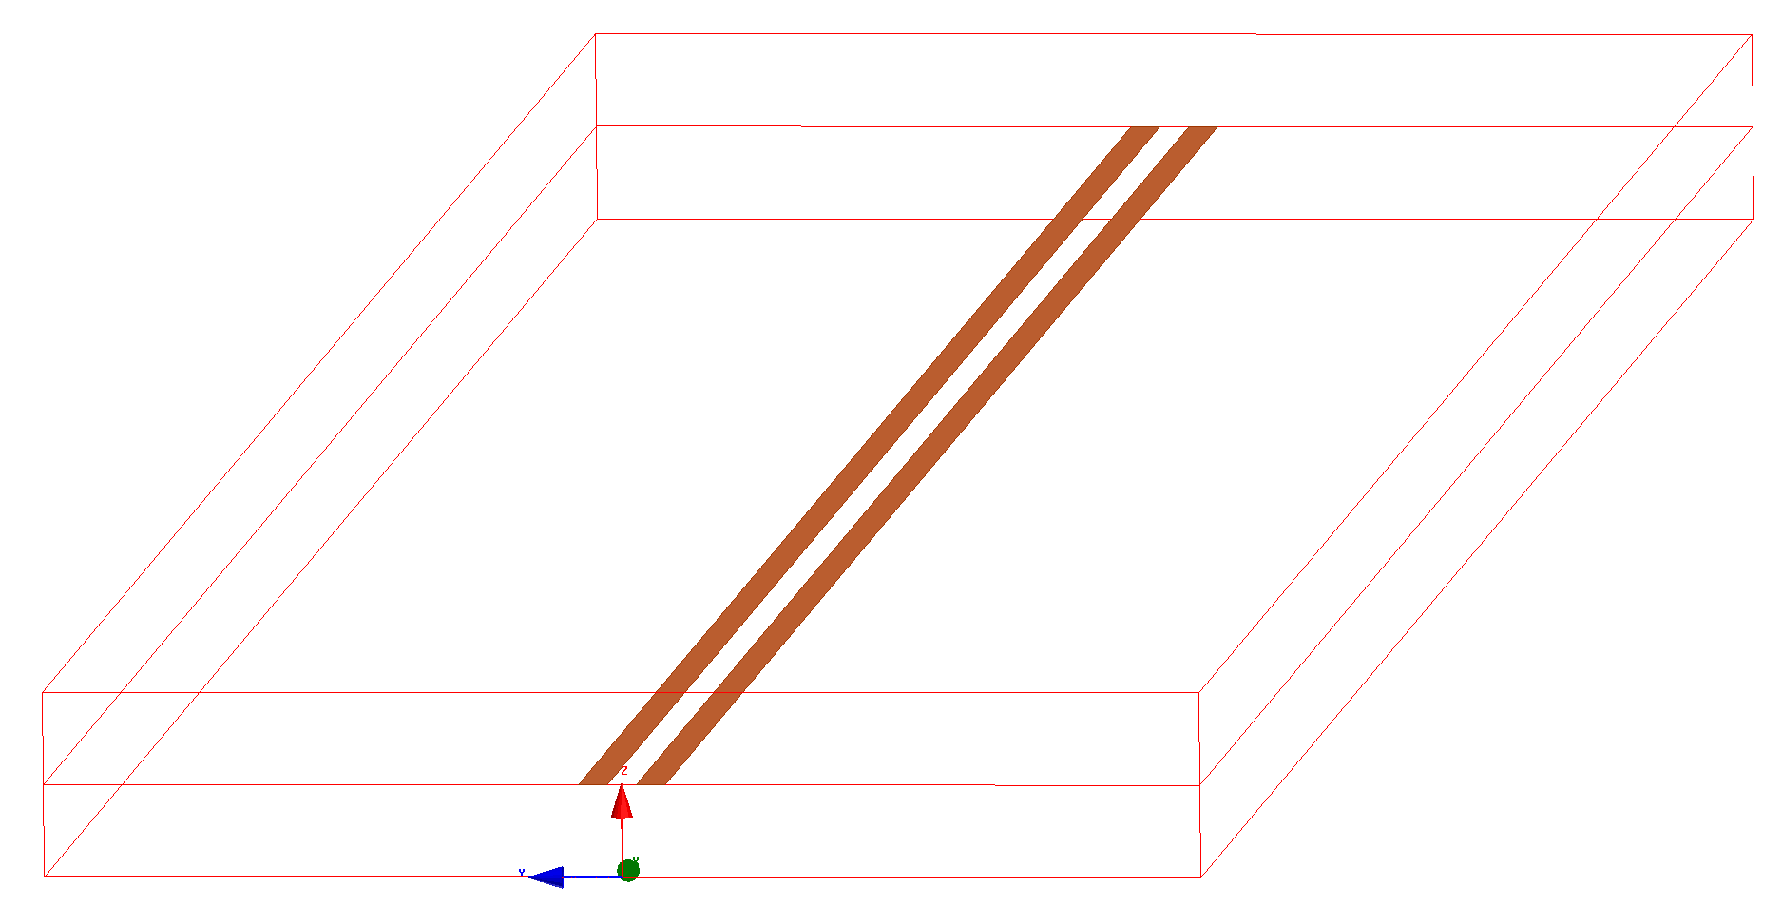
Port 1
Port 2
Figure 14. Twin-wire line geometry.
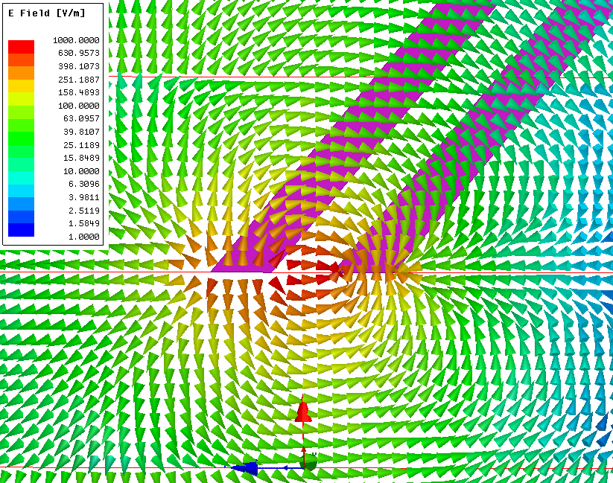
Figure 15. Electric field lines in the twin-wire transmission line.

You will find under Results in the project tree the reflection and transmission coefficient for this line. Observe the reflection and transmission coefficients of the twin-wire line, and the field distribution under Field Overlays>E Field>Vector_E1. You can also right click on Vector_E1 and Animate to observe how the field lines behave (going from one line to the other alternately).

Dipole connected to twin wire line
In this course, we focus on antennas, but the study of transmission line theory is very helpful to understand their behaviour. Additionally, transmission lines are needed to connect any radio emitter/receiver to an antenna. With this exercise, we emphasize these two points, starting from a transmission line with an open end, which we bend to create a resonant dipole connected to the port through of a fragment of twin-wire transmission line.
In this case, we use the model B2.Twin_Wire_Dipole, which is a modified version of B1.TwinWire_Line, in which we removed port 2. This modification leads to an open-circuited line connected with a single port. Also, two new variables are added, that control the length of the arms of the dipole, and the bending angle.

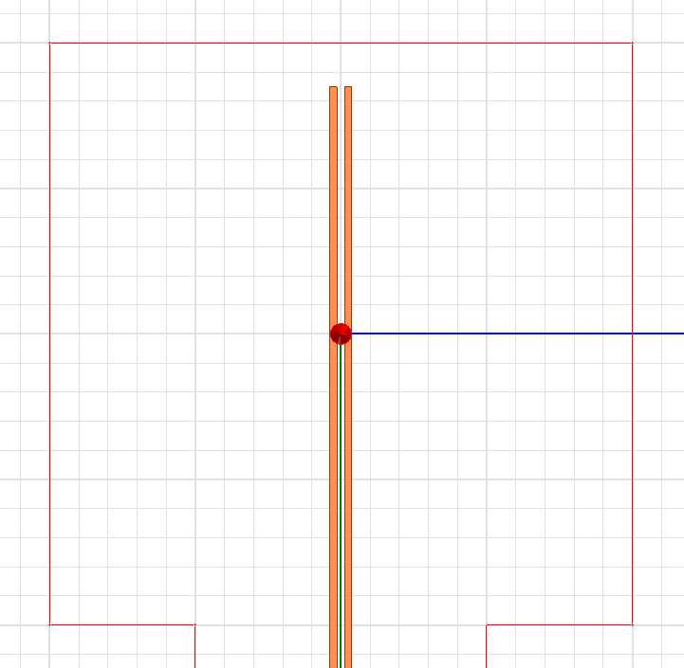 | 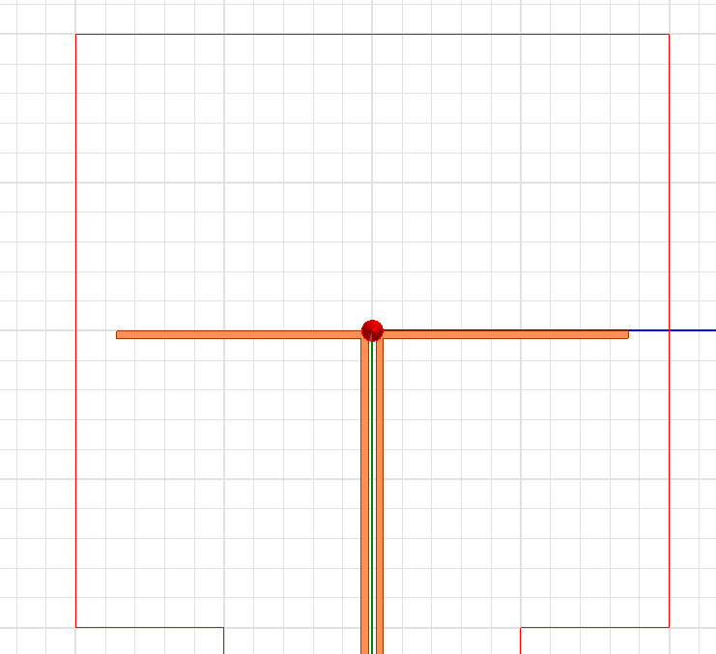
Figure 16. Twin-wire transmission line on its open end (left) and of the resonant dipole (right).
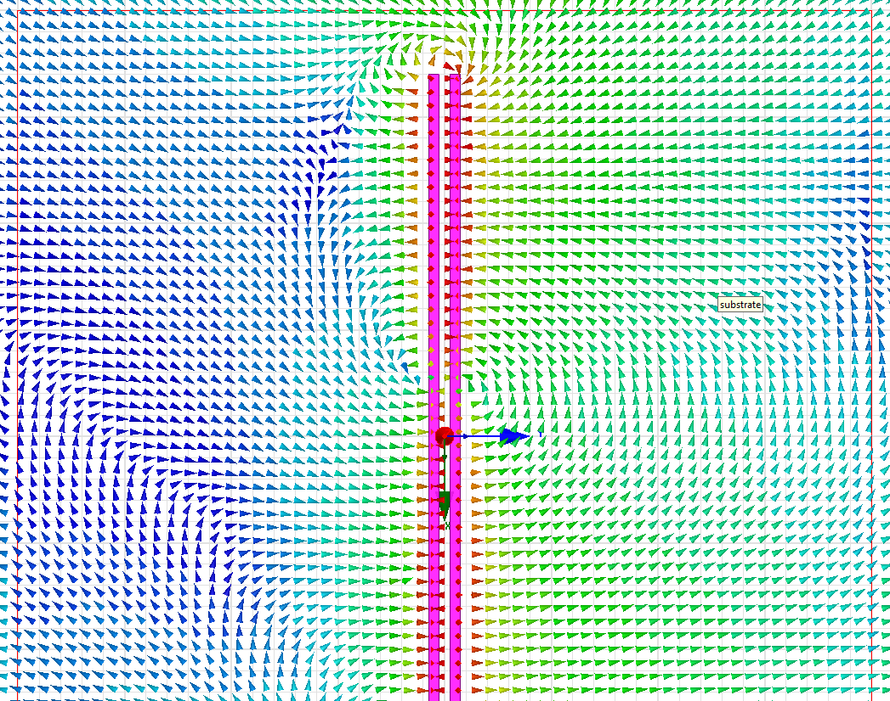 | 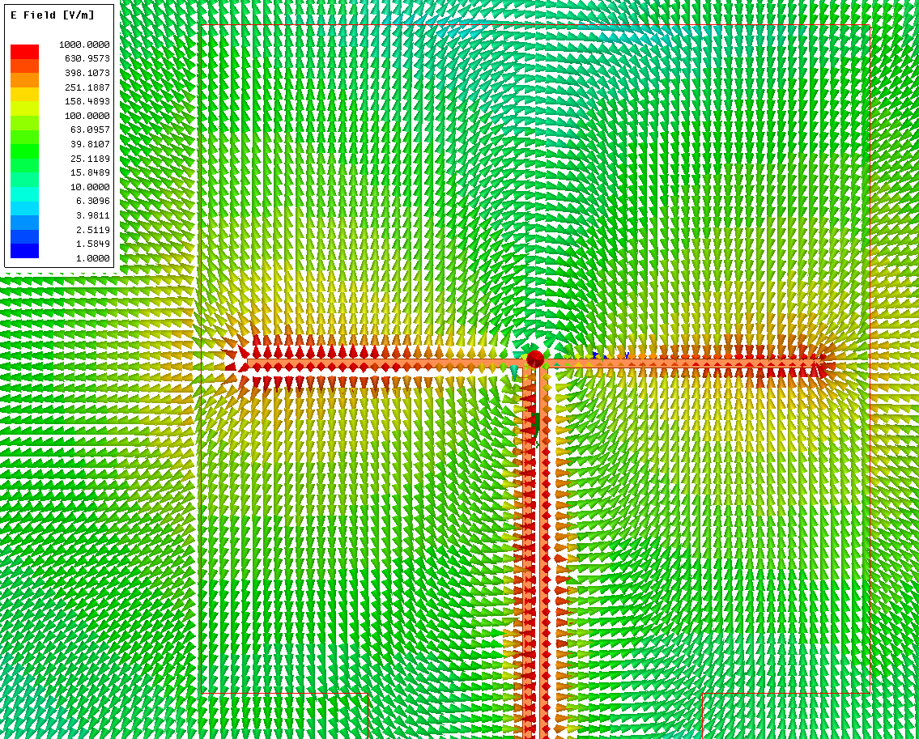
Figure 17. E field distribution of the twin-wire transmission line on its open end (left) and of the resonant dipole (right).

By changing the parameter “dipole_angle”, you can control the bending angle of a fragment of the line, as shown in Figure 16. Observe how the field distribution, radiation pattern, and radiation efficiencies change with the different bending angles. What can you say about the radiation efficiency (the ratio of how much power the antenna is able to radiate) of the dipole depending on the bending angle, and why?
With the parameter “arm_length”, you can change the length of the dipole. For the fully bent dipole (dipole_angle=90º), increase or decrease by 3-4mm the length and observe how the reflection coefficient changes.

PART 3: WIRE ANTENAS - DIPOLES AND MONOPOLES

Dipole connected to twin wire line

Half-wavelength dipole
The goal of this section is to develop a half-wavelength dipole antenna tuned to resonate at a frequency of 2.45GHz, while examining various parameters such as the reflection coefficient, input impedance, current distribution, and radiation pattern.
First, open the file 2025_AntennaCourse_Part3_WireAntennas_StudentVersion.aedt, and then the design A.Dipole_Antenna, which includes the model of a dipole antenna. In this model, the design parameters are defined as described in the following Table.

Variable name | Nominal value | Variable Description
dip_length | 60mm | Total length of the dipole (including the two arms).
dip_diam | 1mm | Controls the width of the dipole. It is the diameter of a cylindrical wire.
feed_gap | 0.5mm | Controls the length of the feed port (along the Z axis).
lambda0 | 122.5mm | Wavelength at the operation frequency (2.45GHz) in free space. We use it to set the size of the radiation box (clearance of λ/4 between the antenna and the radiation boundary).
arm_length | dip_length/2 | This parameter sets the length of each arm of the dipole. It is calculated automatically in the model, as half of the variable dip_length.
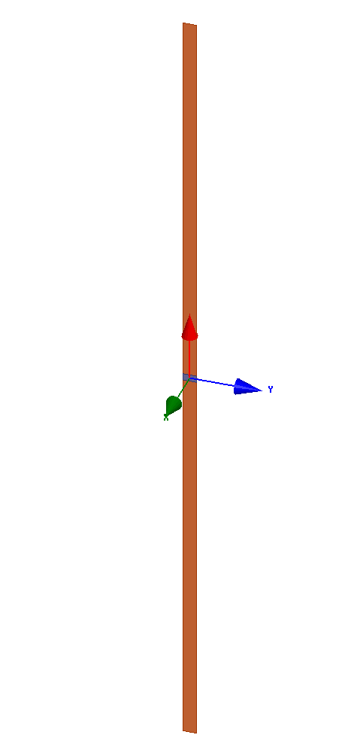
Figure 18. Dipole antenna in ANSYS Electronics Desktop.

- Reflection coefficient ($S_{11},ρ$) and input impedance ($Z_{ant}=Z_{in}$)
We will now create a plot of reflection coefficient ($S_{11}$) plot. To do that it, we follow the next steps: Right click on Reports > Create Modal Solution Data Report > Rectangular plot. The settings in this case are automatically set to show the reflection coefficient in dB, so the student does not need to specify anything, and can just click on New Report.
To show the real and imaginary parts of the input impedance ($Z_{in}$), we select Z parameters on the same window used to plot the reflection coefficient, and then, holding the CTRL key, select im and re on the Function menu, to show both the imaginary and real part of the input impedance, respectively. Then, click New report. You can use the following tables to copy the plots of the reflection coefficient and the input impedance, and then, answer the questions.
Reflection Coefficient in dB

Input impedance (real and imaginary part)

- What is the resonant frequency of the dipole? How do we know at which frequency the antenna resonates? What is the value of reflection coefficient at the resonant frequency, and what is the bandwidth? Note: we consider that the antenna is matched for a reflection coefficient below -10dB.

- What is the value of the input impedance of the dipole ($Z_{in}$) at 2.45 GHz? Does this result match with the theoretical one, seen in the course [1]?

In the model, make small variations to the length of the dipole using the variable dip_length, and run the simulations to adjust the resonant frequency of the dipole to the objective frequency of 2.45 GHz. Then answer the following questions:
- How does the reflection coefficient change with the different lengths?

- For which length of the dipole does the antenna resonate at the desired frequency (2.45GHz)?

- What is the new input impedance at 2.45 GHz? How does it relate to the theoretical input impedance of a half wavelength dipole?

- Radiation pattern
For the antenna with the optimized matching to 2.45GHz, you will now create a 3D radiation pattern plot. To do that, right click on Results, and then Create Far Fields report>3D Polar Plot, and then select Gain, Gain Total and dB, and click on New report. This will show the 3D gain pattern of the antenna in dB.

3D Radiation Pattern

The radiation pattern is often shown through its two main cuts, in a polar or Cartesian plot, which allows to see more clearly the shape of the pattern in each of the two planes. These can be generated as done for the 3D patterns, but selecting the option Radiation pattern instead of 3D polar plot in the Create Far Fields Report deployable menu. The two main cuts that we want to observe here, are the XZ plane (φ=0º), and the XY plane (θ=90º). The angular sweep will be of the θ and φ for the XZ and XY plane, respectively. The primary sweep can be selected in each case in the report window, where we select the quantity we want to plot. The remaining angle can be specified on the tab Families

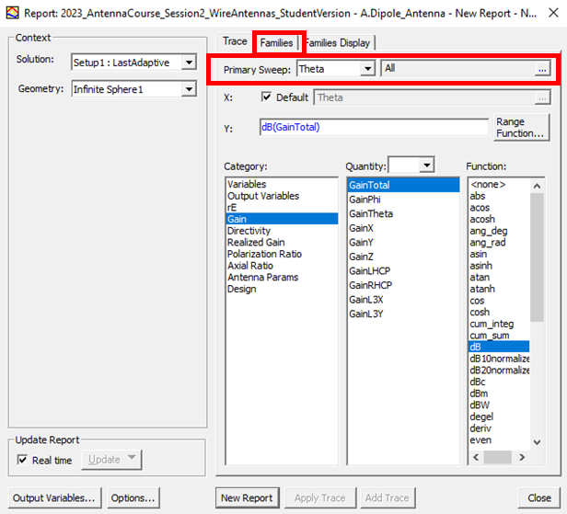

Figure 19. Report window where one can define the primary sweep and select the quantities to plot.

Radiation pattern, cut XZ plane, φ=0º | Radiation pattern, cut XY plane, θ=90º

Answer the following questions.
- Which kind of radiation pattern does the half-wavelength dipole have?

- Why do you think the half-wave dipole is the most used dipole?

Dipole length variation
In this part of the session, we analyse how the behaviour of the dipole changes when its length is modified. In the model, we maintain the same values for all the variables, and we change the dipole length (dip_length) for the next values of the dipole length: λ/4, λ/2, λ, 2λ.

- Current density in the dipole
The current distributions within the dipole are different for each electrical length, and therefore, their radiations patterns are different too. ANSYS Electronics Desktop is a full wave simulator that decomposes the elements of the objects in the models to several tetrahedrons to achieve a solution. For these currents to be shown accurately, the tetrahedrons should be very small, which increases dramatically the simulation time. As these simulations will most likely not finish within the time of the session, you will find the results already simulated for you in the following Figure along with the a theoretical plot from [2]. In the Figure, we show the normalized Complex Magnitude of the current along the length of the dipole (both axes normalized) obtained from ANSYS Electronics Desktop, for several electrical lengths: λ/4, λ/2, λ, 2λ.

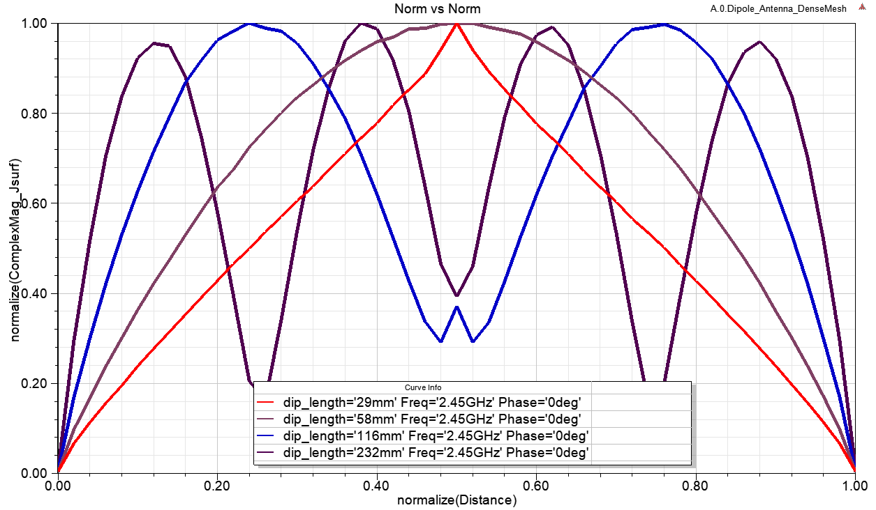

Figure 20. Normalized Complex Magnitude of the current density along the dipole in ANSYS Electronics desktop for the electrical lengths λ/4, λ/2, λ, 2λ.

Figure 21. Theoretical current distributions along the length of a dipole, for the electrical lengths λ/4, λ/2, λ, 1.5λ and 2λ [2]

.
- Radiation pattern analysis
Use the tables below to show the radiation patterns of dipoles of length λ/4, λ/2, 1.5λ, 2λ. After filling the next table with the simulation results, could you explain how the radiation pattern of the dipole antenna changes with the variation of its length?
Polar Gain Radiation Pattern at φ=0º for different lengths of the dipole
λ/4, λ/2, λ, 2λ,

- Which is the relationship between the current distribution and the radiation pattern? Do you know any expression that relates both of them?

Monopole antenna on infinite ground plane
A monopole antenna consists of a straight rod-shaped conductor mounted perpendicularly over some type of conductive surface, called a ground plane. The ANSYS model for the monopole is named B.Monopole_Antenna. In this model, the next design parameters are defined:

Variable name | Nominal value | Variable Description
dip_diam | 0.5mm | Controls the width of the monopole.
feed_gap | 0.5mm | Controls the length of the feed port (along the Z axis).
lambda0 | 122.5mm | Wavelength at the operation frequency (2.45GHz) in free space. We use it to set the size of the radiation box (clearance of λ/4 between the antenna and the radiation boundary).
arm_length | 28.5mm | This parameter sets the length of each arm of the monopole.
dip_diam | 0.5mm | Width of the monopole. It is the diameter of a cylindrical wire.
ground_w | 50mm | Controls the size of the ground (when it is not set up as an infinite ground plane when defining the Perfect E boundary condition).

The antenna is composed of an infinite ground plane and a wire of a specific length (length) and radius (radius) mounted perpendicularly over the ground plane. The wire is fed at the extreme that is closest to the ground plane.
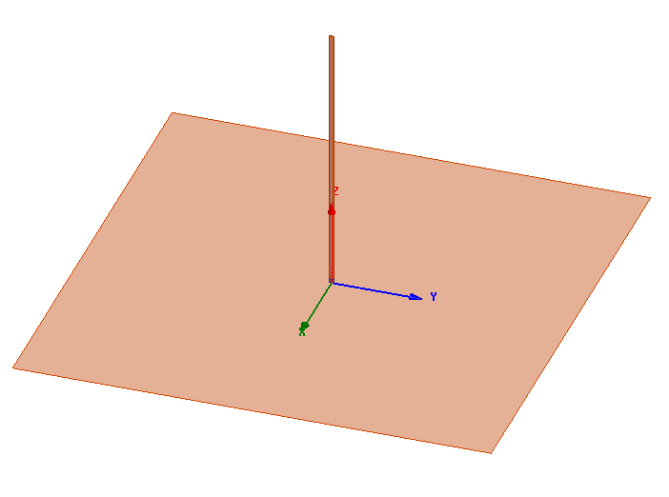
Figure 22. Designed monopole antenna in ANSYS Electronics Desktop.

- Reflection coefficient and input impedance
Use the following tables to show the reflection coefficient of monopole, and its input impedance.

Reflection coefficient

Input impedance

- Radiation pattern
Use the following tables to show the 3D radiation pattern of the monopole and its main relevant cut (XZ or YZ plane). The pattern cut in XY plane is not relevant in this case, as due to the presence of the infinite ground plane (PEC), the field next to the ground plane should be zero.

3D Radiation Pattern

Polar (φ=0º)
- Compare the input impedance and the max gain of the quarter-wavelength monopole with the ones of the half-wavelength dipole. Explain why these changes happen.

- Which are the advantages of the quarter-wavelength monopole respect to the half-wavelength dipole?

- How will the radiation pattern and peak gain change in the case that the ground plane would be finite? You can check this, it time allows, by removing the “infinite ground” checkbox, on the Perfect Electric boundary set to the ground plane. You can find this on the Project Tree, on Boundaries, and Ground_Plane.

References
[1] A. K. Skrivervik, ‘Rayonnement et antennes: notes du cours’, EPFL.
[2] C. A. Balanis, Antenna Theory: Analysis and Design, 3rd Edition. Hoboken, NJ: Wiley-Blackwell, 2005.

